**Design of the Experiment**

**Between-subjects design:**

**Design**: 2 (*CS-US Size matching:* CS1[CS2] sharing a common size with positive[negative]USs vs. CS2[CS1] sharing a common size with positive[negative]USs) between-subject design. Method factors varied between participants:

* + - *CS size assignment*: CS1/CS2 assigned to size match with positive/negative words
    - *Order of evaluative measures*: IAT before vs. after self-reports
    - *IAT block order* (consistent vs. inconsistent with learning phase).

**Stimuli.** Two nonsense words (MORAG and STRUAN) will serve as CS1 and CS2. Six positive (*Rainbow, Pleasure, Smile, Love, Paradise, Joy*) and six negative adjectives (*War, Cancer, Hate, Hell, Misery, Vomit*) will serve as USs.  
**Participants.** Data-collection will be via the Prolific website (prolific.achttps://prolific.ac/). We will stop data-collection as soon as 200 participants have completed the experiment on the Prolific website. This will allow us to have good power (> 0.80) to observe an EC effect (*d* = 0.50) driven by US-CS size matching, at alpha = 0.05.

**Procedure.** EC 🡪 Evaluative measures 🡪 Exploratory Questions

*EC training phase*. Participants receive three blocks of 16 trials (48 total) consisting of two different types of trials. In one type of trial CS1 is presented in the same sized font as positive words and a different sized font as negative words. In another type of trial CS2 is presented in the same sized font as negative words and a different sized font as positive words. Note that each trial will contain three stimuli simultaneously presented onscreen: a neutral word (MORAG or STRUAN) and positive and negatively valenced words. All three stimuli will initially be presented for 5000ms, after which all stimuli will be removed, followed by an inter-trial interval of 750ms, and the next trial. Stimuli will always be presented in the same color (white) and the sizes of the fonts will be randomly counterbalanced across trials (e.g., sometimes a CS and US share a small font and at other times they share a large font).

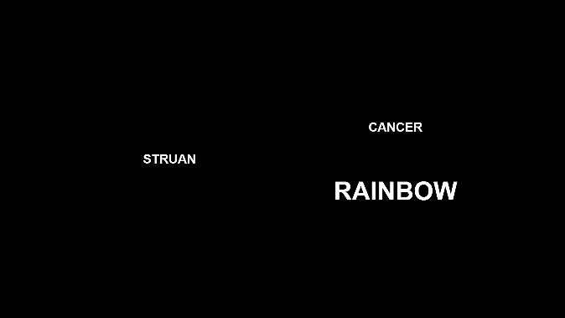 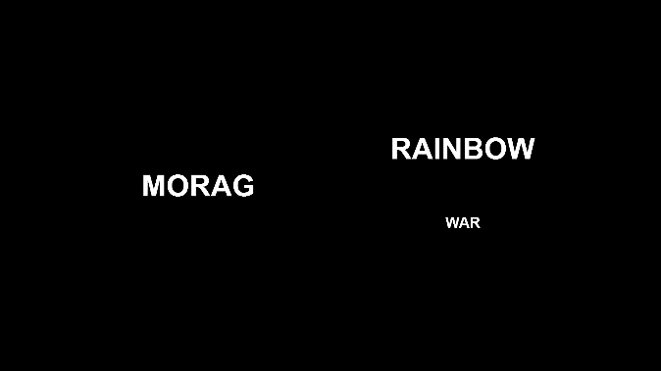

*Figure 1.* Examples of two types of trials in the EC phase.

*Implicit attitude*

Participants will perform an IAT measuring implicit evaluations of CS1 vs. CS2:   
The IAT involves the categories “CS1” and “CS2” and “Good” and “Bad”  
  
IAT Procedure:

a. Instructions: “In the next part you will have to categorize items into groups as fast as you can.”

b. 20 practice trials sorting CS1 on the left and CS2 on the right.   
  
c. 20 practice trials sorting positive words on the left and negative words on the right.

d. 20 test trials CS1 and positive words using one key and CS2 and negative words using another key.

e. 40 test trials CS1 and positive words using one key and CS2 and negative words using another key.

f. 20 practice trials CS2 on the left and CS1 on the right.

g. 20 test trials CS2 and positive on the left and CS1 and negative on the right.

h. 40 test trials CS2 and positive on the left and CS1 and negative on the right.

NOTE: IAT stimuli are:

* + - CS1
    - CS2
    - Positive words: *Fantastic, Great, Nice, Good, Pleasant, Wonderful, Amazing, Happy*
    - Negative words: *Terrible, Disgusting, Nasty, Horrible, Sick, Awful, Sad, Unpleasant*

*Explicit attitude*. Participants give explicit ratings of the two CSs by answering the question:

*“Please rate the above item using the scale below*  
options: -5 =Negative, 5= Neutral, +5= Positive

options: -5 =I Dislike it, 5= Neutral, +5= I Like it

options: -5 =Bad, 5= Neutral, +5= Good

options: -5 =Unpleasant, 5= Neutral, +5= Pleasant

*Intention measure*. Participants are presented with two brand products labeled with either CS1 or CS2. They are asked to indicate which of these products they would try and given the following options: “I would try CS1, I would try CS2, I would try CS1 and CS2, I would try neither, I don’t know”.

Finally, participants answer the following exploratory questions about the EC task:  
  
 *CS-US Contingency awareness*. “In the second part of the experiment we presented MORAG/STRUAN along with two other words. Did...?

“Those two other words always have a positive meaning", "Those two other words always have a negative meaning", "One word always have a positive meaning and the other a negative meaning", "I don’t remember"

*CS-US Size Contingency Awareness*. Questions were as follows:

“Think back to the first part of the experiment (where the three words were presented together onscreen). Was MORAG always presented in:"

“Think back to the first part of the experiment (where the three words were presented together onscreen). Was STRUAN always presented in:"

Response options: The same size letters as POSITIVE Words", "The same size letters as NEGATIVE words", "I don’t remember"

*Manipulation check*.

“Did you ever take notes (or write down) what happened in order to help you figure out what was going on? Please be honest here (you will receive payment regardless of what you say).”

*Demand Compliance (explicit):* Earlier you rated MORAG and STRUAN as being either positive, neutral, or negative. Did you base your ratings NOT on how you actually felt about those words but on what you thought the researchers wanted you to say?"

("Yes", "No", "I don’t know")

*Demand compliance (implicit).* Earlier you completed the Implicit Association Test (see below). Did you base your performance in that task NOT on your best efforts to perform the categorizations as quickly and accurately as possible but on your attempt to influence your speed or accuracy in order to go along with what you thought the researchers wanted you to feel about the words?

("Yes", "No", "I don’t know")

*Reactance. (Explicit).* Earlier you rated MORAG and STRUAN as being either positive, neutral, or negative. Did you consciously resist what you thought the researchers wanted you to feel about those words?"

("Yes", "No", "I don’t know")

*Reactance (implicit).* Earlier you completed the Implicit Association Test (see below). Did you try to influence your speed or accuracy in order to consciously resist what you thought the researchers wanted you to feel about those words"

("Yes", "No", "I don’t know")

Influence Awareness.

“Think back to the first part of the experiment. During that part of the study, we presented MORAG and Positive Words in the same sized letters and STRUAN and Negative Words in the same sized letters. Did you notice this during the study? Please be honest here"

“Do you think that the fact that MORAG and Positive words were presented in the same sized letters (and that STRUAN and Negative Words were presented in the same sized letters) influenced how you rated or otherwise responded towards MORAG or STRUAN? Please be honest here"

Note: the CS and US identity in this question was counterbalanced across experimental conditions.